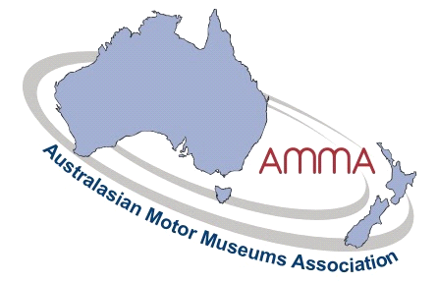
Winter Newsletter 2026
Hello everyone,
I must apologise for the lack of recent notifications to members. I have had some demons to deal with, and similarly our secretary and magazine editor Ian Bone has had to surrender his position with AMMA. I wish to thank Ian for all his work with previous entertaining magazines, he will be impossible to replace.
With Trump’s war on terrorism, the World has been on hold for several months. The information on the World Forum in France has been slow to come through with no registrations as yet. I have been assured that it will go ahead as planned, they are still calling for presentations, if anyone is interested.
Our financial year has come around again, and I am pleased to say that membership renewals are steadily coming in. Your $2.00 per week barely covers website admin fees, brochure printing and postage. We do our best to promote the association at every opportunity. Hard copy brochures are almost a thing of the past, and some tourist information centres now do not have facilities to carry them. However, many of our museum visitors are always keen to take a copy with them on their travels.
From time to time, I am notified of historic vehicle movements, and as AMMA chairman I am pleased to offer any assistance that I can, especially letters of support. Recently I was contact by a gentleman here in Australia that had found an early thirties Holden roadster bodied Chevrolet in Europe and is returning it to Australia. The seller has been adamant with the price, and with the Aussie dollar conversion, brings it within the luxury car tax bracket. And of course, all the asbestos has to be removed. How ridiculous a situation we have here now. A few have tried to change the rules without success. The importer would welcome some financial help, possibly from some of the Holden museums here, in exchange for display rights. I believe it is extremely rare and a beautiful thing. If anyone is interested in helping, they can contact me and I can refer them on.
In my previous newsletters I have mentioned a proposal to hold a mini conference in Canberra, in March next year, for members and allied associations to tackle problems such as the above, and discuss other issues involved around our industry. We may be able to entice some politicians along to air our grievances. However, response has so far been disappointing, and without a better response, we are not sure if it will be worth continuing with.
As a simple reminder, any member wishing to delve into the AMMA archives on the website, the username is ‘motor’, and the password is ‘museum@amma’.
That is all for this issue, please contact me or Ian Oliver if you would like to be a part of the conference. We are all volunteers trying to support our association to the best of our ability.
Yours faithfully
Colin Kiel
AMMA Chairman.

