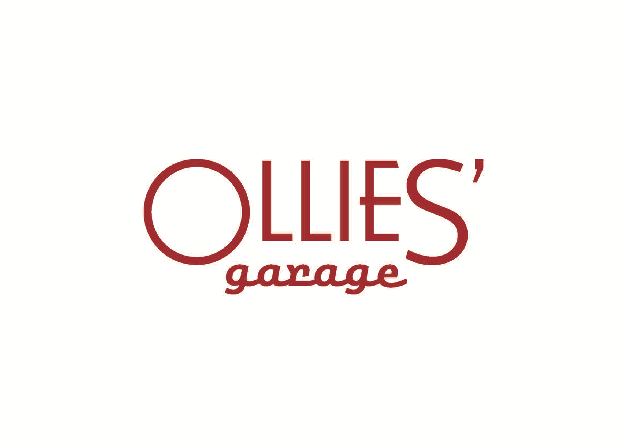

CASE STUDY

VIRTUAL REALITY INTERACTIVE TOUR (VRIT)

OLLIES’ GARAGE
AND THE CANBERRA SHOWROOM OF THE SIR HENRY ROYCE FOUNDATION (SHRF)

Prepared by
Ian Oliver
November 2024

Contents

Page

Acknowledgement 3

Introduction 3

What is a Virtual Reality Interactive Tour (VRIT) 4

The Matterport Software 5

Ollies’ Garage Performance Statistics 7

Other Museums using VRIT 8

Conclusion – The Future is Virtual 9

Attachment A: Current Video and Proposed Video Content 10

Attachment B: Matterport Explanation and Terms 11

Acknowledgement

The Virtual Reality Interactive Tour (VRIT) used by Ollies’ Garage and the Canberra Showroom of The Sir Henry Royce Foundation is a collaborative effort between Ollies’ Garage, Can’t be Stopped Productions, MKVI Media and Matterport. With the introduction of this platform to Ollies’ Garage, Cieran Jordan of MKVI Media has been instrumental in the research, production, creation and directing of display content, editing, uploading etc.

Introduction

Ollies’ Garage and the Canberra Showroom of the SHRF was officially opened on the 6th July 2024 with the premises open to the public on one Saturday per month from 1st August 2024 and by appointment to other groups such as car clubs.
From early August 2024 Ollies’ Garage has been introduced to the idea of creating Virtual Reality Interactive Tours (VRIT) using Matterport 3D technology by MKVI Media, its newly created website, YouTube videos, and other social media. The purpose of this case study is to present the results of the first three months activity utilising virtual reality tours.

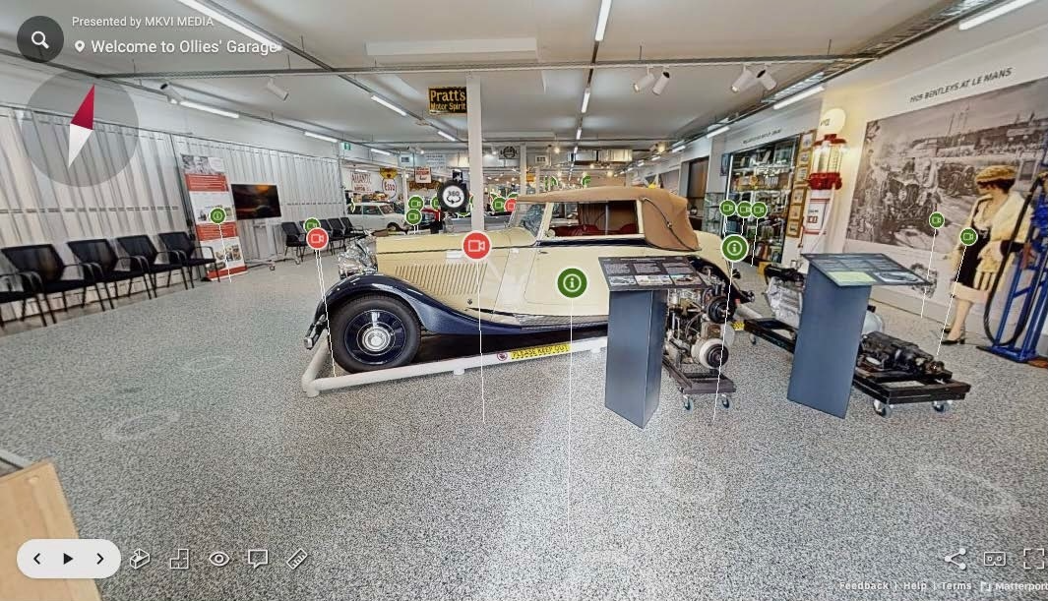
Ollies' Garage scene of the entry to the Virtual Reality Interaction Tour.

What is a Virtual Reality Interactive Tour (VRIT)

The phrase virtual tour is very widely used to describe videos and photographic-based media.
A virtual reality tour is a simulation of an existing location, usually composed of a sequence of videos, still images or 360-degree images. It may also use other multimedia elements such as sound effects, music, narration, text and floor map.
A virtual reality interactive tour or a virtual reality self-guided tour allows viewer control of the tour, thereby controlling the items viewed and time devoted to individual scenes and content. The user has an experience of having a more lifelike experience, eliminating the need for physical attendance and visitation. This opens up the premises and contents of the tour to being open 24/7 on the web, having global exposure and the ability to have inspections such as 360 degree camera viewings of the internals of a vehicle, saving the user time and the provider costs such as wages, electricity and consumables.
History
The first example of a virtual tour was a museum visitor interpretive tour in 1994, consisting of 'walk-through' of a 3D reconstruction of Dudley Castle in England as it was in 1550. One of the first users of a virtual tour was Queen Elizabeth 11, when she officially opened the visitor centre in June 1994. Because the Queen's officials had requested titles, descriptions and instructions of all activities, the system was named and described as: "Virtual Tour, being a cross between Virtual Reality and Royal Tour."^{[4]}
Video-based
With the expansion of video on the internet, video-based virtual tours are growing in popularity. Video cameras are used to pan and walk-through real subject properties. The benefit of this method is that the point of view is constantly changing throughout a pan. However, capturing high-quality video requires significantly more technical skill and equipment than taking digital still pictures. Video also eliminates viewer control of the tour. Therefore, the tour is the same for all viewers and subject is chosen by the videographer. Editing digital video requires proficiency with video editing software and has higher computer hardware requirements. Also, displaying video over the internet requires more bandwidth. Due to these difficulties, the task of creating video-based tours is often left to professionals.
Applications
Virtual tours are used extensively for universities, sport venues, real estate and hospitality industries, museums, etc. More recently the technology is used by planners to measure the internal detail of existing structures, risk assessment of buildings and contents. Virtual tours can allow a user to view an environment without needing to be present physically. Currently, a variety of industries use such technology to help market their services and product. Over the last few years, the quality and accessibility of virtual tours have improved considerably, with some websites allowing the user to navigate the tours by clicking on maps or integrated floor plans. Virtual tours can be especially useful for universities and real-estate operators who want to attract students, tenants, and buyers, while eliminating the cost of travel to numerous locations. 3D virtual tour technology has been increasingly used in the documentation and preservation of historic properties that are at risk of being razed or undergoing restricted public access.

A study done by the PEW Research Group showed that more than 5 million Americans watched virtual tours every day in 2004. Now, twenty years later, and following Covid 19, Virtual Reality Tours with no face to face contact, makes this medium extremely popular. This is particularly the case with the younger generation and the more tech savvy time-poor older generation, as it can be delivered from the comfort of the home or from anywhere with internet connectivity.

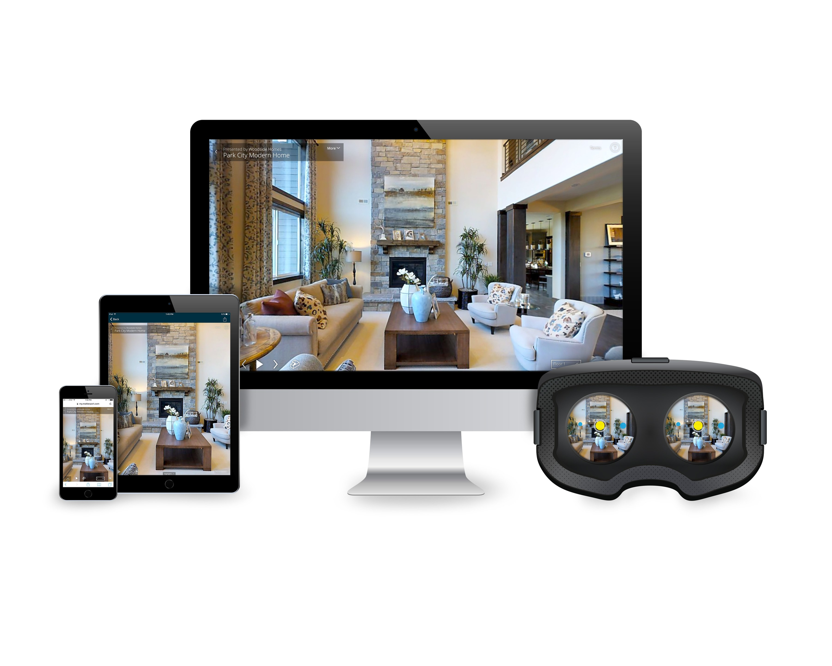
A Virtual Reality Interactive Tour is able to be used by phone, tablet, computer or even a headset for a more immersive experience.

The Matterport Software

Matterport is a cutting-edge technology company that specializes in creating immersive 3D virtual tours. Founded in 2011, Matterport's mission is to transform the way people experience and interact with spaces. The company's proprietary technology uses advanced cameras and software to capture and render 3D models of real-world environments, allowing users to explore these spaces from anywhere in the world.

Matterport's technology combines 3D scanning, photography, and virtual reality to create detailed and accurate representations of physical spaces. The process begins with a Matterport camera, which captures high-resolution images and depth data. This data is then processed by Matterport's cloud-based platform, which stitches the images together to create a seamless 3D model.

Key Features of Matterport Technology:
- High-Resolution Imaging: Matterport cameras capture images at resolutions up to 134 megapixels, ensuring crisp and clear visuals.
- Depth Sensing: The cameras use infrared sensors to measure distances and create accurate depth maps of the scanned spaces.
- Cloud Processing: Once the data is captured, it is uploaded to Matterport's cloud platform, where advanced algorithms process and render the 3D models.
- Interactive Navigation: Users can navigate through the 3D models using an intuitive interface, allowing them to explore the space as if they were physically present.
- Virtual Reality Integration: Matterport models can be viewed in VR headsets, providing an immersive and lifelike experience.

Benefits of Virtual Reality Interactive Tours:
- Accessibility: Ability to open 24 hours a day, 7 days a week, 365 days a year. VR tours can be accessed from anywhere, eliminating geographical barriers, opening to a wider audience and making it easier for people to explore spaces remotely.
- Convenience: Users can take tours at their own pace and on their own schedule, without the need for appointments or guided tours.
- Engagement: The immersive nature of VR tours provides a more engaging and interactive experience compared to static images or videos.
- Cost-Effective: VR tours can reduce the need for in-person visits, saving time and travel expenses for both the provider and the user.
- Detailed Exploration: Users can explore every nook and cranny of a space, gaining a comprehensive understanding of its layout and features.
- More visibility: as it opens to the inside contents of displays not available to physical walk-through viewings. For instance, the inside of a vehicle can be panned 360 -degrees and zoomed in to provide photo images.
- Passive Income Opportunities: Opportunity for additional income via the YouTube advertising platform or paid for viewings.

Ollies’ Garage Performance Statistics to 31st October 2024

Since the opening of Ollies’ Garage and the Canberra Showroom of the SHRF there has been work in progress to create and upload video content and instal the technology to allow Virtual Reality Interactive Tours. This is still in early stages and shows promising results over traditional physical walk in displays.

YouTube Videos Detailed Introductions Shorts Total
Views (past 60 days) 25,563 1,568 1,722 28,853
No of Videos 4 16 3 23
Average Views per video 6,396 98 574 1,254
Average Views per day 426 26 29 481
Attendances
Attendance at public showroom Events since opening 14.8% 355
Attendance Virtual Reality Interactive Tours 85.2% 2,037
Total Visits Physical and Web VRIT 2,392

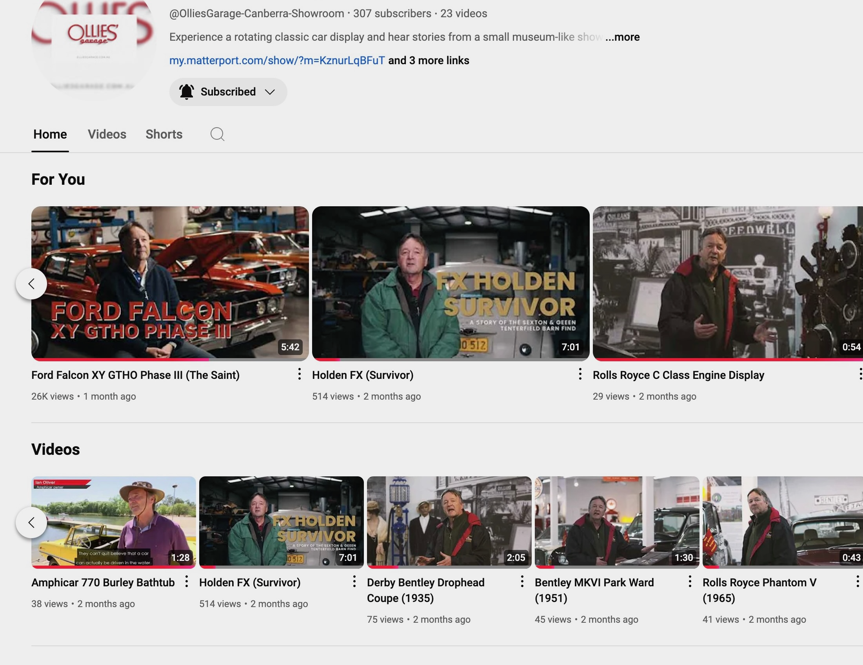
YouTube extract showing the Channel and some of the current video content.

Other Museums using Virtual Reality and VRIT

From the Canberra Fire Brigade Museum in Canberra to the Museum Of Freemasonry in Sydney, and even the National Gallery of Victoria (NGV) in Melbourne (the oldest and most visited gallery in Australia), VR is indeed becoming a powerful tool to expand audience reach. This technology allows museums to offer immersive experiences to people who might not be able to visit in person.

Also, around the world we are seeing leading Museums like the Smithsonian Museums in the USA, Musée du Louvre, Paris, The National Gallery, London, National Museum United States Air Force, The State Hermitage Museum in Russia, NASA (National Aeronautics & Space Administration) in USA , Motor Museum of Japan (the largest in Japan) all embrace virtual reality.

It is little wonder that Mercedes Museum, one of the most famous and popular automotive museums in the world, has just announced on the 31st October 2024, that they are joining the growing number of worldwide motoring museums offering virtual reality experiences. With over 13 million visitors since its opening in 2006, They aim to extend into the digital realm offering a new dimension in presenting Mercedes-Benz Classic to reach a wider audience than would be traditionally possible.

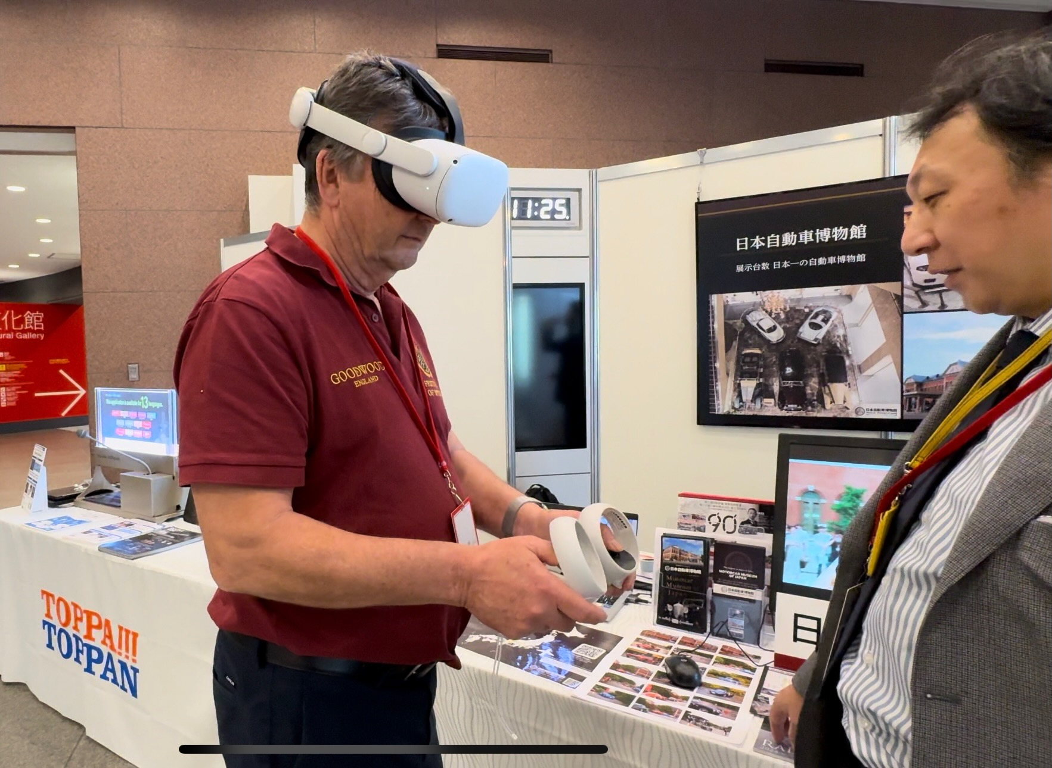
Attending the 2024 World Forum of Motor Museums in Japan recently, Ian Oliver obtains a Virtual Tour of the Motor Museum of Japan with headsets for a more immersive experience.

Conclusion – The Future is Virtual

The success of technological advancements in any commercial venture depends on the investment and professionalism made. In today's digital age, opening business to the world wide web and delivering content that is both relevant and engaging is crucial for success.

The potential of 3D technology to transform spaces, such as car showroom museums, is particularly exciting. By blurring the lines between the physical and digital, 3D technology can offer innovative and immersive experiences that appeal to a broader audience. As this technology continues to evolve, it will undoubtedly open up new possibilities for engaging and entertaining viewers in ways that traditional methods cannot match.

Future innovations such as 3D Hologram technology offers yet another layer of unique and immersive display experience. Its splicing capability, high-resolution display, and operation now enable it to be a more perfect choice for museums and displays. It is now a product worthy of research and possible future investment by Ollies’ Garage and the Canberra Showroom of the SHRF.

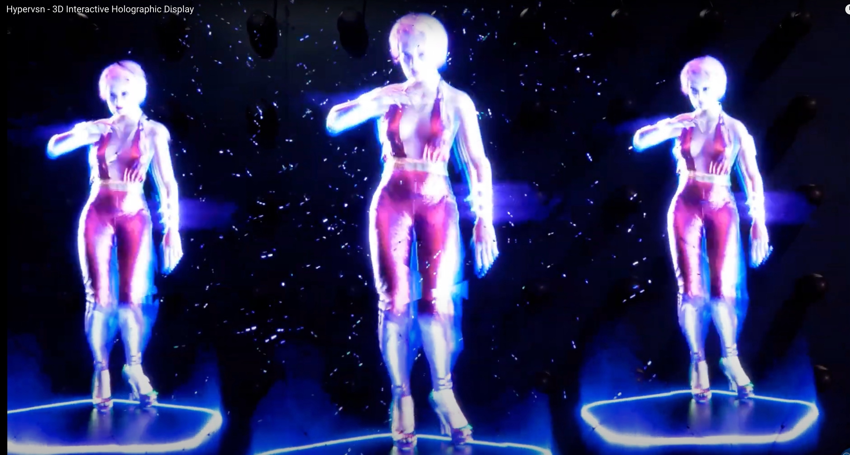

Hypervsn – People. Can we have a hologram for Sir Henry Royce, WO Bentley, Peter Brock?

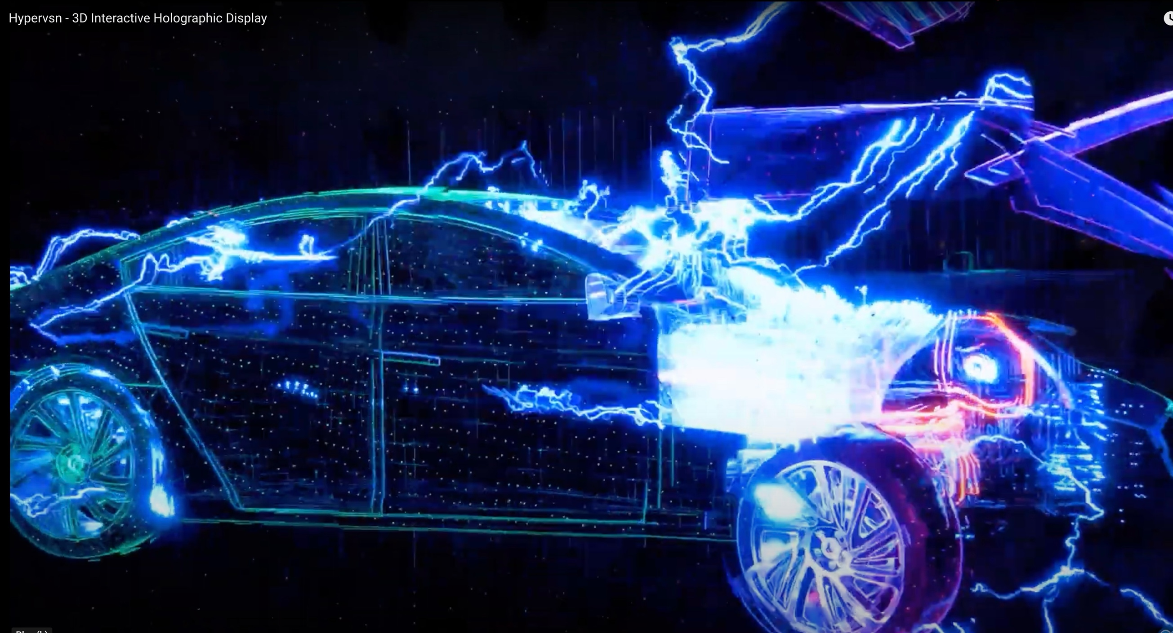

Hypervsn – Vehicles. Could it be a hologram of a Rolls-Royce, Bentley or other marque?

Attachment A:

Ollies' Garage Current & Proposed Videos on YouTube 31/10/2024
 | Previous Channel |  | Ollies’ Garage Channel
length mins | Views | Days | Views | Days

Current Type
Ollies' Animated logo Logo 0.11 28 60
Ollies' Garage VR Tour Explainer Video Explainer VR 1.5 128 30
Ford Falcon XY GTHO Phase III (The Saint) Detail 5.42 2629 14 25000 30
Holden FX (Survivor) Detail 7 3400 760 407 60
Amphicar 770 Burley Bathtub Introduction 1.28 35 60
Ford Falcon XY GTHO Phase 3 (1971) Introduction 1.05 302 60
Welcome to Ollies' Garage and SHRF Canberra Showroom Introduction to be re done 1.15 213 60
Welcome to Ollies' Garage Virtual Tour Introduction to be re done 0.41 73 60
BMW E30 M3 (1987) Introduction 1.05 229 14 41 60
Mercedes Benz SL500 (1985) Introduction 1.24 744 14 41 60
Holden HT Monaro 350 GTS (1969) Introduction 1.11 280 14
Ford Falcon XT GT (1968) Introduction 1.2 2082 14 223 60
Derby Bentley Drophead Coupe (1935) Introduction 2.04 72 60
Holden FX (Barn Find) & EK #1 Survivors Introduction 1.39 176 21
Rolls Royce C Class Engine Display Introduction 0.54 46 14 27 60
Rolls Royce Phantom V (1965) Introduction 0.37 233 14 42 60
Bentley MKVI Park Ward (1951) Introduction 1.3 149 14 43 60
Petrol Powered Aussie Dodgem Car!! Short (loaded 1/11/2024 - over 1,000 views in 2 days)
Hyundai at Goodwood Short 0.26 540 14
Getting out of the Ferarri Short 0.41 587 14
Holden HT Monaro 350 GTS (1969) Short 0.58 595 14
9512 28853

Future Proposed

RR & Bentleys - Survivor Cars Current Display Introduction Current vehicles without introductions approx. 12
Non RR & Bentleys for Future Displays Introduction Approx 15
100 Year Anniversary Bentley Detail Celebration of 1st winning WO Benley at 1924 LeMans and 2024 Bentley
Wayne Corinthian Bowser Detail A find and restoration of one of the most collectable Australian Bowsers
Ollies' Shed & Workshop Detail Featuring Ollies' Early Holdens & Restoration works in Queanbeyan
Ollies' Mancave Detail Explore a home designed around theman cave with 7 Lifts!!
Bentley Mark VI Special (The Rikky & Pete Story & engine) Detail A perfectly sound car to a cut out roof, a prime mover to a roadster The Rooster & The Bentley - The Horn button of John Laws Detail How a rooster family crest is discovered and now defines the car

Nurburgring Experience in a Porsche 992 GT3 Detail Being strapped in and experiencing the most exhilarating taxi ride Nurburgring Experience in a self drive VW Golf Detail Take a very fast drive around the track with bikes and cars LeMans Classic Experience Detail Experience one of the best motor venues in Europe
Goodwood Festival of Speed Experience Detail Experience one of the best motor events in UK with classic cars

Owning a Swamp Boat Detail Why would you own a swamp boat
Owning a Model T Ford Detail Henry Ford makes a massive impact on providing affordable transport Shipping a Bentley to the UK for a car reunion Detail 1951 Bentley Park Ward gets an invite to Earls Court Reunion Show in UK World's Greatest Marathon Race Detail Rerun of the 1968 Australian leg of the London to Sydney
Repco Reliability Trial 1979 Detail Rerun of the event in 2019 40th Anniversary

Ollies' Beer Truck Short A Suzuki Mighty Boy used for all sorts ofl trips incl replacing the beer kegs
The Alternative to EV Detail Driving a classic on alternative fuel - are we there yet?
Should we be buying EV's - Controversy video Detail Save the planet and your pocket by not falling into the EV trap

The fate of Private Car Collections and Car Museums Detail Explore Virtual Reality Self Guided Tours and how opening 24/7 can help

Playlists - Car Museums and Private Collections in AU Detail Explore other Car Collections and Museums in Australia and NZ
Playlists - Intern'al Museums - Europe, UK, USA,Japan Detail Explore other Car Collections and Museums around the world Playlists - Australian Motoring Legends Detail The Australian legendary drivers like Peter Brock, Allan Moffat stories Playlists - Australian Motor Racing Circuits Detail We have the existing Mount Panorama at Bathurst-There are others

Attachment B:

Matterport Explanation and Terms

(VIT) is a three-dimensional system that creates a realistic, fully immersive digital environment. It combines proprietary hardware and software solutions to establish this digital space. By scanning an area with our top-of-the-line immersive camera, we generate a 3D tour that can be accessed online, allowing for a virtual 360-degree walkthrough of the space. In essence, it acts as fully immersive 3D media that helps businesses showcase their properties or services, ultimately attracting more customers.

A space can range from a single room to an office or shop with multiple rooms on a single floor, or even to a large multi-story building. We can also scan vehicles such as cars, boats, caravans, and planes for sale or lease, enabling potential buyers to inspect them regardless of their location.

During the scanning process, the camera captures 360-degree images with a resolution exceeding 100 megapixels. It also collects 3D data using a built-in LiDAR system, which allows for precise measurements and the construction of a 3D model of the space using the point cloud data it captures. Scans can be ready within 48 hours, ensuring that the virtual tour is delivered promptly.

How does it work?
The Camera has a Cortex AI-powered platform that transforms scans, beyond seamlessly stitching the various scans together to create an accurate 3D scan The AI can also recognise objects or people within the space, and create compelling virtual tours.

Key features
- Mattertags
— These custom pop-ups can be anchored anywhere in the scan and can include anything from notations and comments to interesting information and relevant links. Mattertags can even contain additional photo/video content and e-commerce integrations!
- Blur Brush
— If you’re scanning a public space but don’t have photo permission from the people in the scan, the AI-powered Blur Brush can identify human faces and automatically anonymize them for you.
- Dollhouse view
— An essential part of the experience, the dollhouse view is a photorealistic, interactive 3D floorplan. “More than 2D photos, which present a single view, “Dollhouse Views provide a 3D perspective to help people visualize room flow and the spatial relationship between spaces — and provide a way to navigate quickly to any space of interest.”
- Measurement tool
— Since all scans are completely to scale, the measurement mode can be used to accurately measure anything captured within the 3D model.
- Guided tours
— We don’t just provide accurate 3D renderings, the platform also comes equipped with a tool to turn digital twins into custom virtual tours. “Whether you want to guide contractors through repairs on a construction site, or promote key features of a property for sale or rent, you can create a great tour in minutes.”
Examples in action
Now that we have an idea of how it works and what it can do, let’s take a closer look at three of the most prevalent industries Capture Visual Marketing (CVM) has leveraged this cutting-edge technology for:
- Architecture and design
— One of the best things about the platform is the resulting scan can be used to generate a litany of additional 4K-quality content types, including photos/videos, JPGs, PDFs, GIFs, CAD files, and more. The precision accuracy and 3D granularity generated by CAD (computer-aided design) files have proven particularly useful for architects tasked with evaluating or renovating a space, or interior designers planning to redecorate.
- Historic properties and museums
— For operations reliant on an in-person experience, like historic properties and museums, the outbreak of the pandemic was a watershed moment. But thanks to this platform, MKVI Media has been able to help several high-profile historic venues produce immersive virtual tours of their spaces — including a virtual tour of Ollies' Garage that was viewed over 2090 times in 14 weeks.
- Hospitals and medical facilities
— Going to the doctor’s office can be anxiety-inducing, especially if you have an appointment at a big, labyrinthine hospital or are visiting an office for the first time. MKVI Media can help hospitals and medical institutions combat patient anxiety with guided 3D tours designed to familiarise people with the facility before they show up for an appointment. Virtual 3D tours have also been a great recruitment tool for hospitals and pharmaceuticals looking to attract new talent.
Of course, these are just three industry-specific examples in action. Imagine all the positive uses in a myriad of different ways, including bolstering insurance and property claims, improving ADA compliance, showcasing new products, and even facilitating virtual employee training.
The future is virtual
Blurring the line between the physical and digital, our 3D technology has the potential to transform the way organisations across industries understand and utilise space. Given our tried-and-tested success, we’re confident scan technology will continue to expand and evolve in innovative and exciting ways.
We’re also committed to continue exploring and advancing new technology whenever possible. With this capability in place, we can augment virtual tours to provide a new context for in-person visitors.

Examples of car museums and museum links:

Zach's Garage | Barn Museum

Mitsubishi Motors - Egypt

Zach's Garage | Icon & Pre-War Museum

Lamborghini Brussels - V12 Mitica Mostra

TVR Car Club booth - NEC Classic Car Show 2016

San Diego Automotive Museum

Museum Bad Hersfeld Erdgeschoss

Museum Of Freemasonry

Canberra Fire Brigade Museum

Zoological Museum-Giza Zoo

Bentley MKVI

Bentley GT Blackspeed

Video:
How to take a Virtual Tour at the Harvard Museum of the Ancient Near East

25 Best & Famous Virtual Museum Tours:
https://allvirtualreality.com/learning/best-famous-virtual-museum-tours.html

Ciaran Jordan - Producer
+61 405 263 016
Cantbestoppedproductions@gmail.com
www.cantbestoppedproductions.com
Content//Film//TVC//Music Videos//Corporate//Management

